INTERNATIONAL HUMAN RIGHTS DAY
DATE: 10/12/2021

Today, on the occasion of “International Human Rights Day” , Political Science Department of Barbhag College in collaboration with Internal Quality Assurance Cell (IQAC) of Barbhag College organised a meeting to celebrate the day. The meeting was presided over by Dr. Sanjib Kumar Goswami, HOD, Department of English, Kamrup College, Nalbari. Through his speech, he raised serious concern over various issues of human rights violation at the community level. As Chief Guest, Dr. Ankurjyoti Bhuyan, Assistant Professor, Department of Political Science, Kumar Bhaskar Varma Sanskrit and Ancient Studies University graced the meeting. The topic of his speech was “Human Rights protection and Promotion at International Context and Role of India”. He threw light on the development of the idea of human rights and what is actually happening worldwide in the name of protecting human rights with the help of statistical data prepared by international bodies. He critically analysed the role of state apparatus in protecting human rights. Again, Nivedita Goswami, Principal-in-charge of Barbhag College and Dr. Karuna Baruah, Academic Supervisor of Barbhag College were also present. They also talked about the need of creating awareness about human rights among students. As part of the celebration, a quiz was also conducted. There were short drama, song, poem recitation as parts of the day-long celebration of the day. Altogether 126 people, including social workers, faculties, student and official staffs of Barbhag College were present, who contributed towards the successful celebration of the day.

SIGNATURE

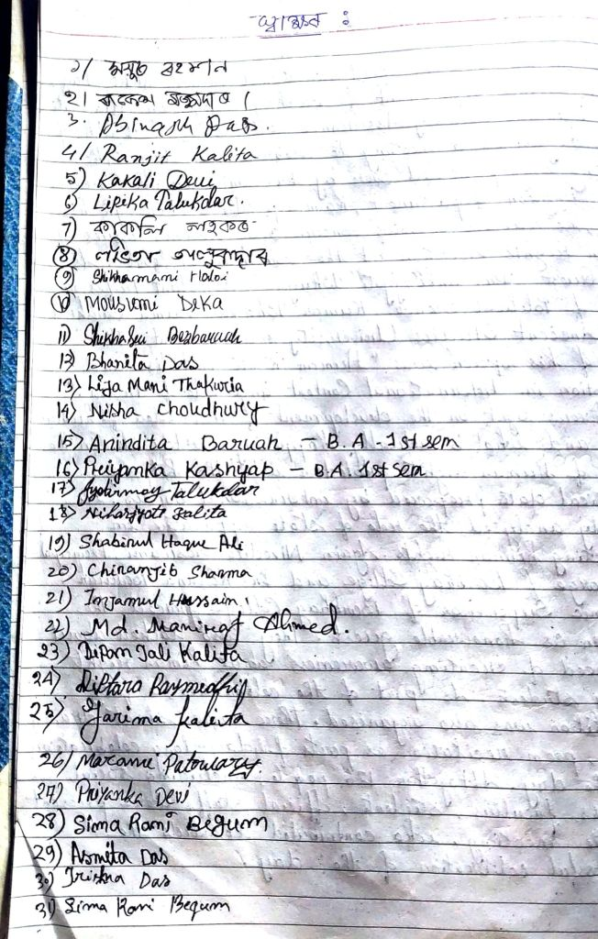
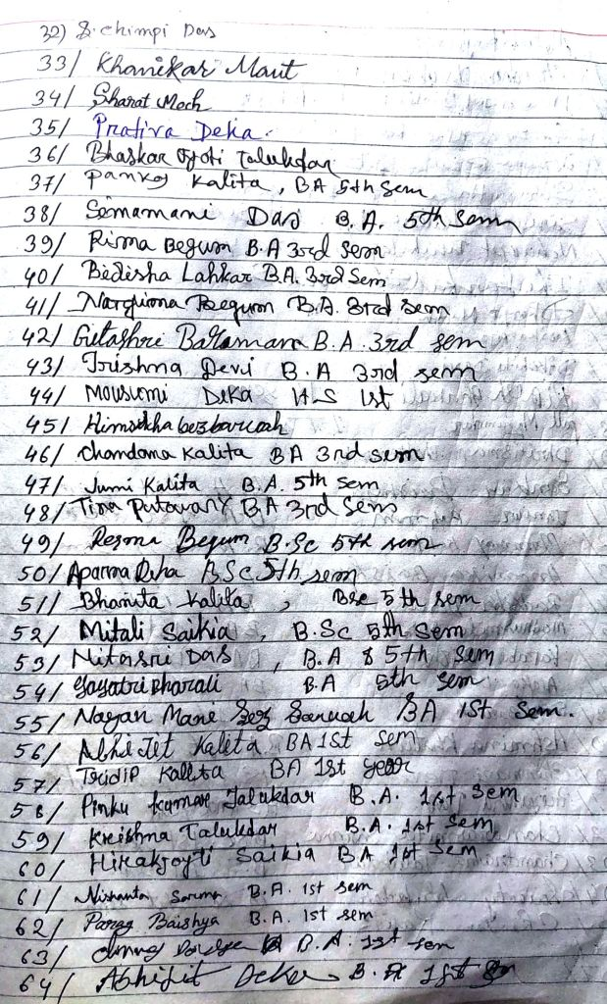
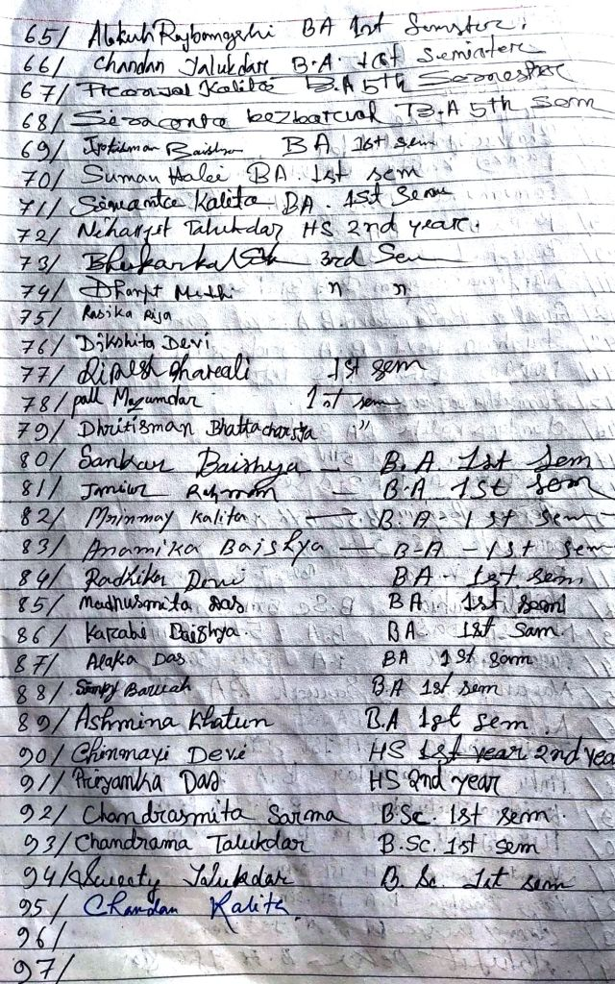
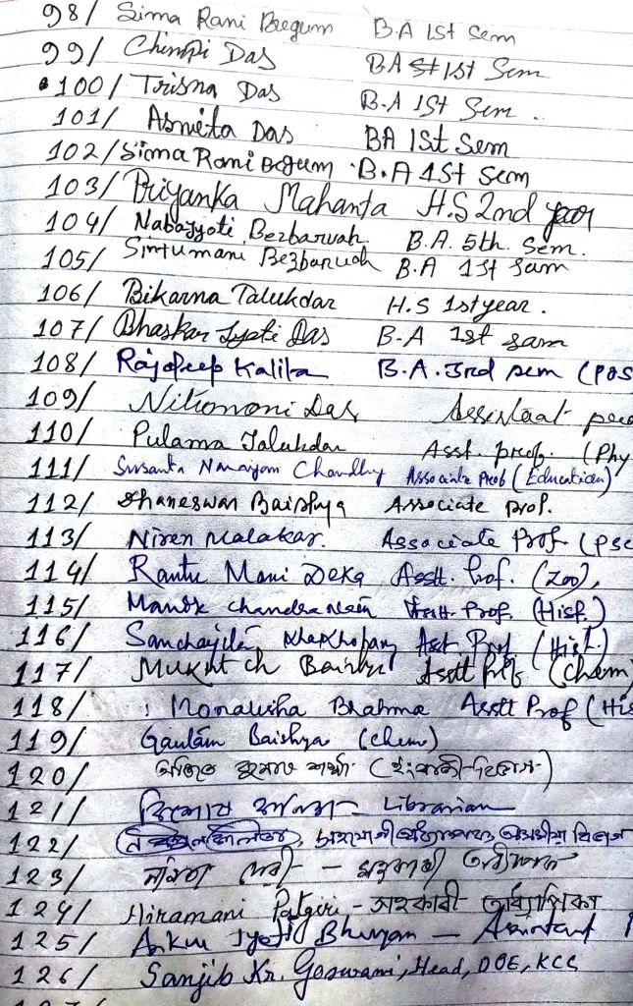
PHOTOS
1. Inauguration of the programme by Ajit Kr Sarma, Associate Professor, English Department by paying tribute to the martyrs who sacrificed their life to protect human rights

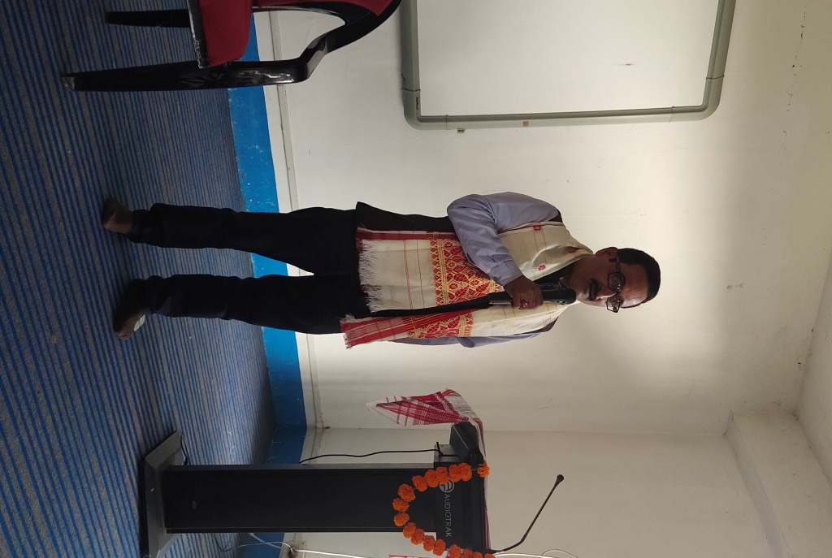
2. Quiz Competition
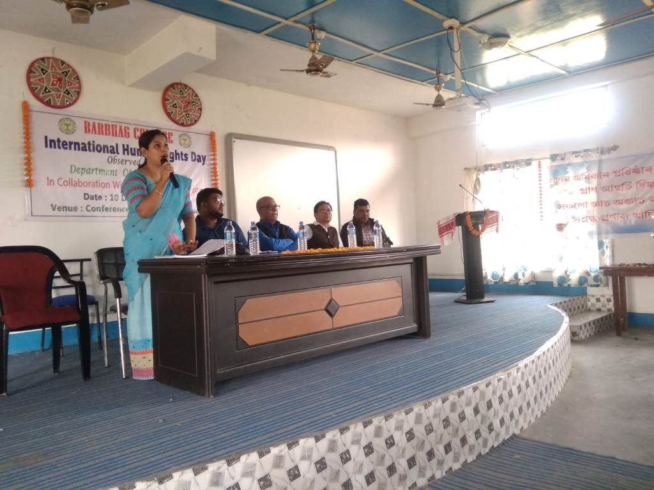

3. Dr. Sanjib Kumar Goswami Presiding over the meeting
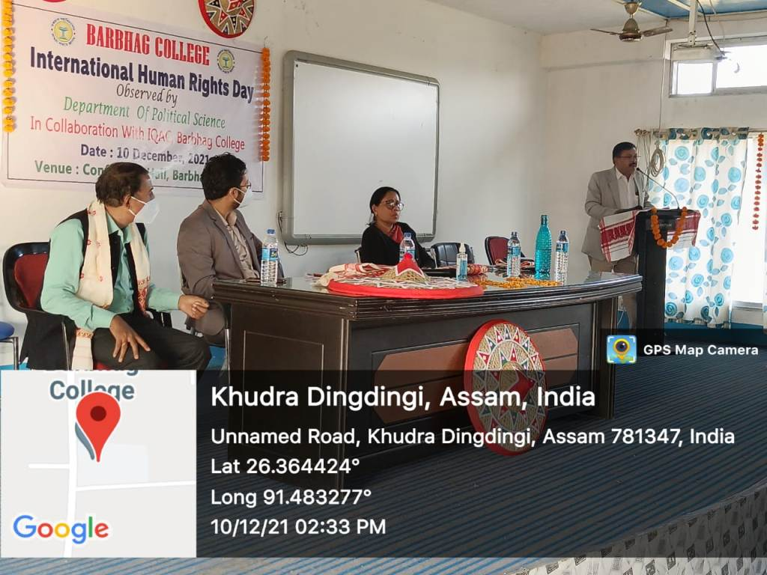

4. Dr. Ankurjyoti Bhuyan delivering his speech

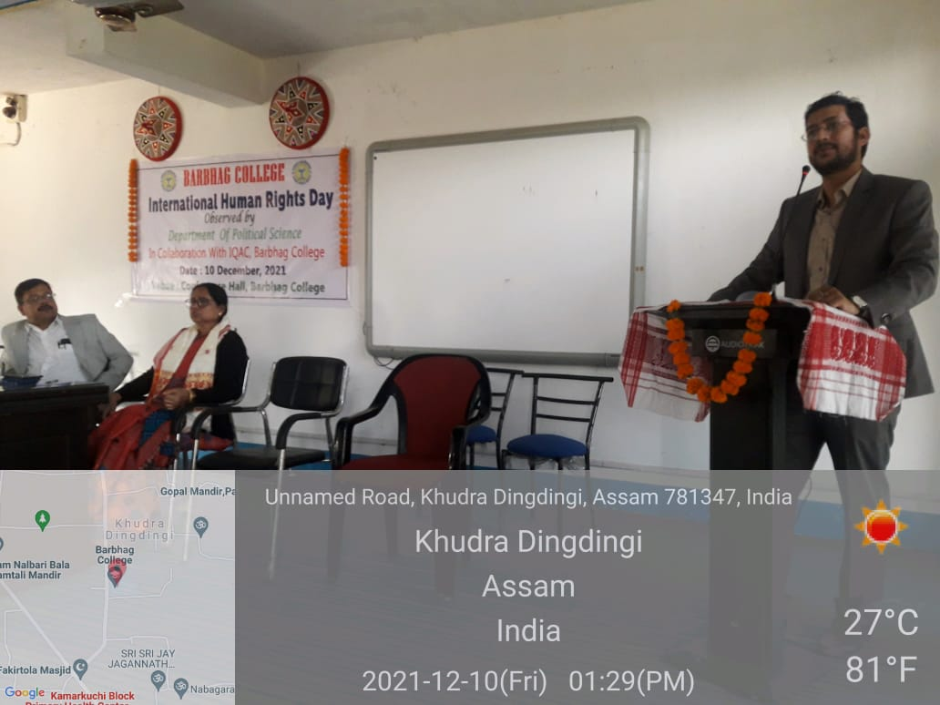

5. Skit by students
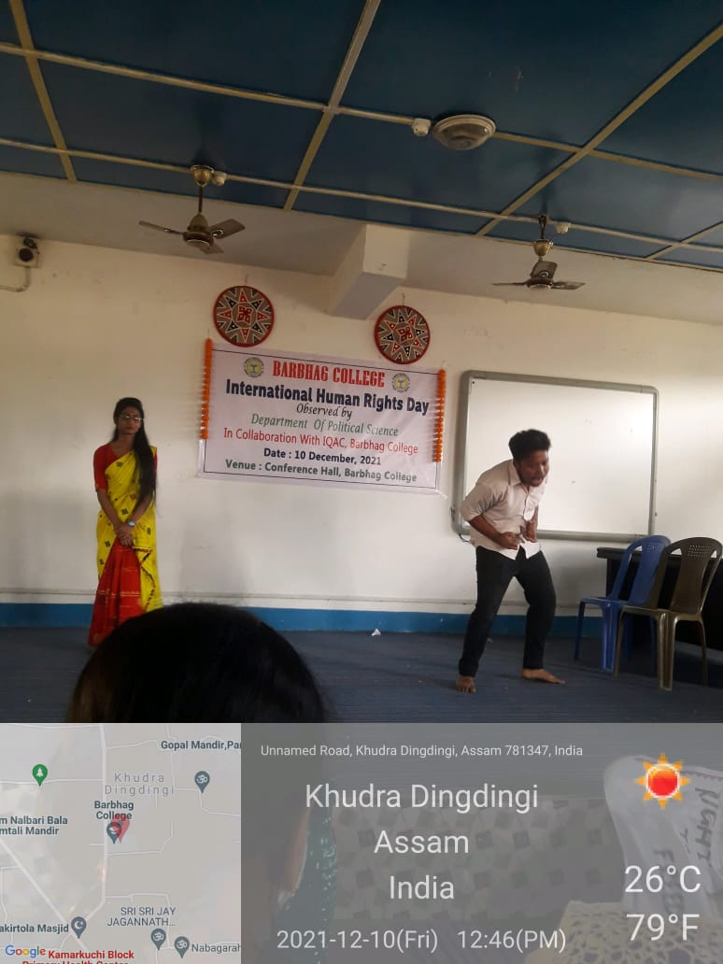

6. People present

